

|  |
| --- |
| Link2Care Agenda |
| Quarter 4 [2021] |
| December 1, 2021: 2:00 – 3:00 PM |

# Action Items

|  |
| --- |
| 1. Study Update |
| 1. Placeholder |
|  |
|  |

Contents

Action Items 1

Study Participants 3

Phone and Clincard Breakdown 5

Phone Terminations 6

Visit Compliance 7

COVID -19 7

EMA Completion Rates 8

Arrests 10

Bridge Case Session Minutes 11

Recruitment 12

Link2Care Study Update

**N =** **329 people screened as of** **November 23, 2021**

# Study Participants

**Table 1.** Demographic characteristics of all people screened for study inclusion.

| **Characteristic** | **Screened-in** | **Screened-out** |
| --- | --- | --- |
| (n = 329) | (n = 53) |
| **Age in years**, mean (sd) | 39.9 (10.9) | 44.7 (11.5) |
|  |  |  |
| **Gender**, n(%) |  |  |
| Male | 280 (85.1) | 48 (90.6) |
| Female | 44 (13.4) | 5 (9.4) |
| Other | 5 (1.5) | 0 (0.0) |
|  |  |  |
| **Race**, n(%) |  |  |
| Black or African American | 203 (61.7) | 42 (79.2) |
| White | 71 (21.6) | 7 (13.2) |
| Other | 55 (16.7) | 4 (7.5) |
|  |  |  |
| **Ethnicity**, n(%) |  |  |
| Non-Hispanic | 289 (87.8) | 51 (96.2) |
| Hispanic | 40 (12.2) | 2 (3.8) |

**Table 2.** Distribution of reasons for screen-out1.

| **Reason For Screen Out** | **n (%)** |
| --- | --- |
| Score <4 on REALM-SF | 44 (56.4) |
| Score <24 on Mini-Mental State Exam | 12 (15.4) |
| Incorrect Consent Reading | 11 (14.1) |
| Failure to Orient | 4 (5.1) |
| Other | 4 (5.1) |
| Walked Out Prior to Screen Out | 2 (2.6) |
| PT Plans to Move | 1 (1.3) |
| Total | 78 (100.0) |

1. This number is larger than the total number of people screened-out because each person could have been screened out for multiple reasons.

# Phone and ClinCard Breakdown

|  |  |
| --- | --- |
| **Table 3**. Payment card and phone loss. | |
| Total number of ClinCards distributed | 554 |
| Total number of participants with ClinCard replacements | 146 |
| Total number of phones distributed | 311 |
| Total number of participants with phone replacements | 104 |

* 91 Participants had cards replaced 1 time (2 total payment cards).
* 35 Participants had cards replaced 2 times (3 total payment cards).
* 16 Participants had cards replaced 3 times (4 total payment cards).
* 4 Participants had cards replaced 4 times (5 total payment cards).

|  |  |
| --- | --- |
| **Table 4.** Phone distribution and replacement. | |
|  | n (%) |
| Total # of phones distributed overall | n = 311 |
| Total # of participants in phone groups | 199 |
| Total # of participants w/ phone replacements | 104 |
| # of participants w/ phone replacement (**UCM+SP**) | 46 |
| # of participants w/ phone replacement (**L2C**) | 57 |
| # of participants in UCM+SP w/ >1 phone replacement | 4 |
| # of Participants in L2C w/ >1 phone replacement | 3 |

* 97 Participants had phone replaced 1 time (2 phones per participant total).

# Phone Terminations

**Figure 1.** Reasons for phone terminations overall (total = 304).

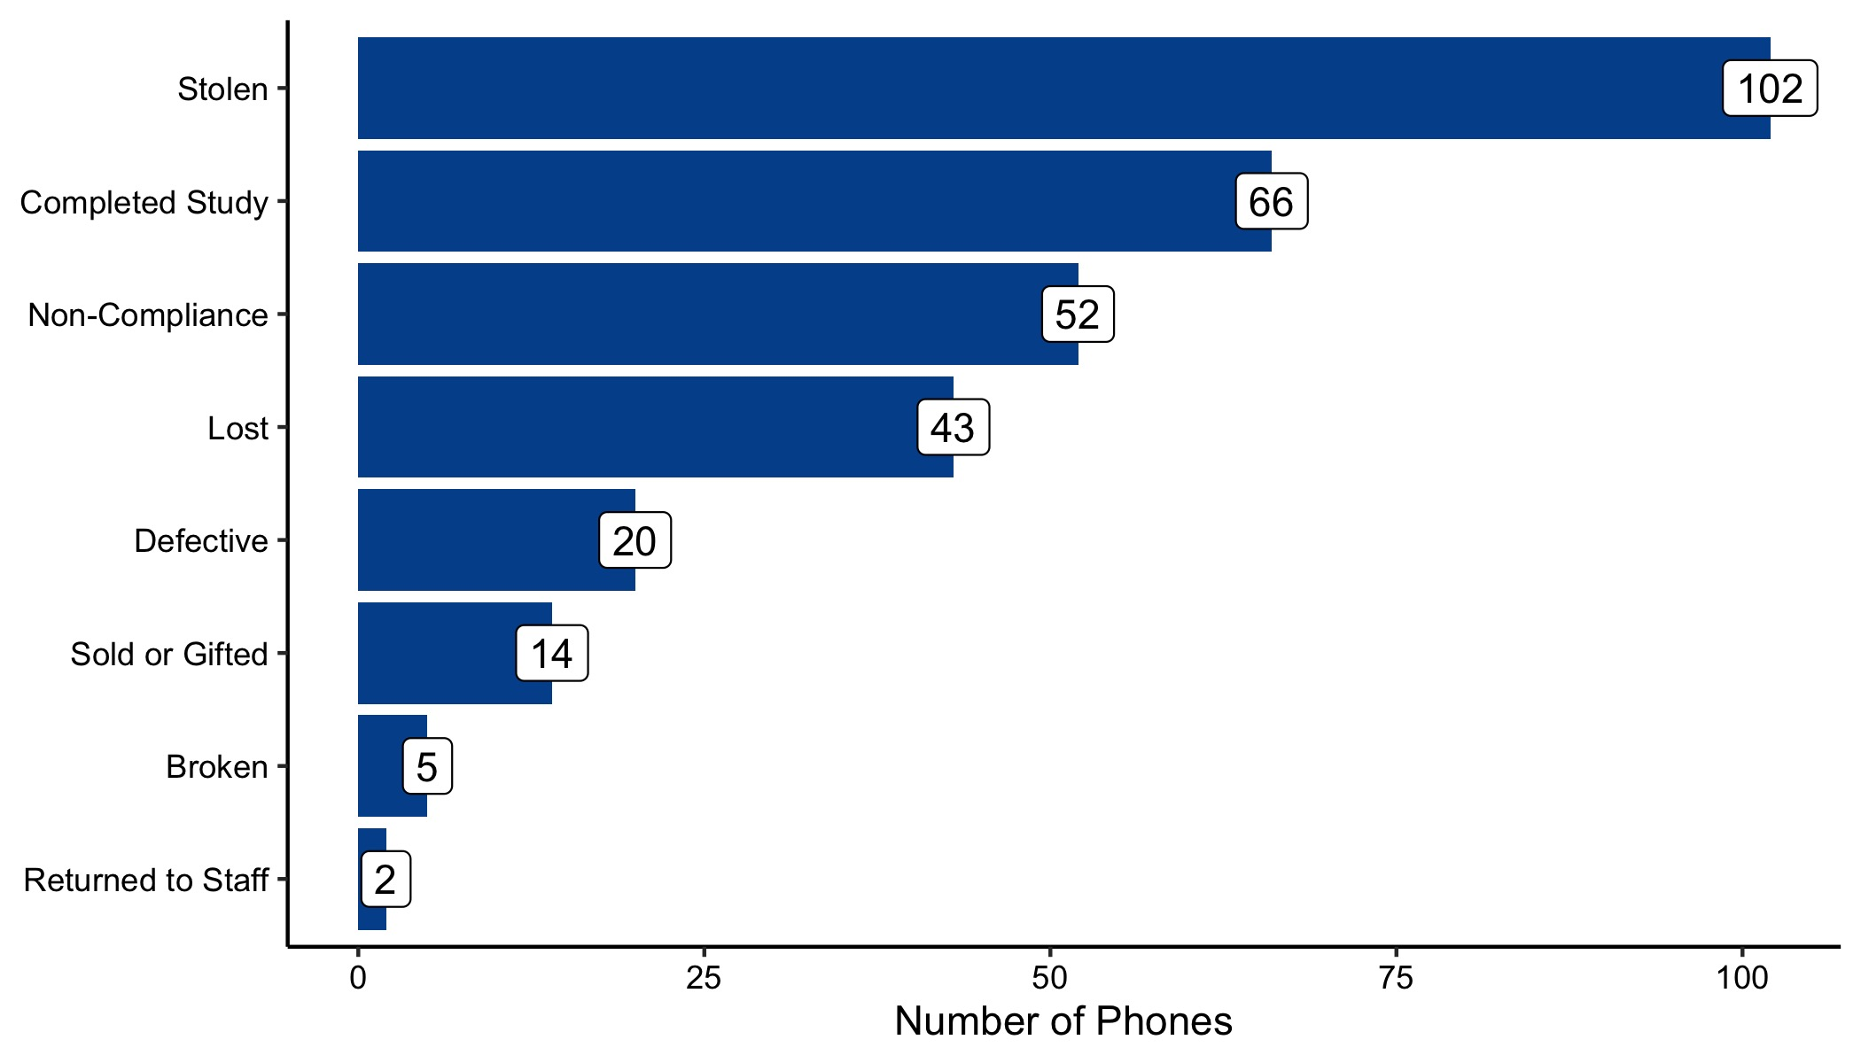

|  |  |  |  |
| --- | --- | --- | --- |
| **Table 5.** Reasons for phone terminations by informed consent form version | | | |
|  | **ICF #1**: Original EMA Structure  (P2001-P2073) | **ICF #2:** 15-Day EMA Comp & Non-compliance  (P2074-2153) | **ICF #3:** Increased EMA Payment  (P2154 and on) |
| **Reasons for Terminations** | **n (column %)** | **n (column %)** | **n (column %)** |
| Stolen | 33 (42.9) | 27 (32.1) | 42 (29.4) |
| Completed Study | 23 (29.9) | 13 (15.5) | 30 (21.0) |
| Non-Compliance | 0 (0.0) | 18 (21.4) | 34 (23.8) |
| Lost | 13 (16.9) | 15 (17.9) | 15 (10.5) |
| Defective | 2 (2.6) | 9 (10.7) | 9 (6.3) |
| Sold or Gifted | 3 (3.9) | 2 (2.4) | 9 (6.3) |
| Returned to Staff | 0 (0.0) | 0 (0.0) | 2 (1.4) |
| Broken | 3 (3.9) | 0 (0.0) | 2 (1.4) |
| **Total** | **77 (100)** | **84 (100)** | **143 (100)** |

# Visit Compliance

|  |  |
| --- | --- |
| **Table 6.** Number and percent of participants per L2C group. | |
| **L2C Group** | **n (percent)** |
| UCM+SP | 101 (30.7) |
| UCM | 102 (31.0) |
| L2C | 98 (29.8) |
| NS V2 | 23 (7.0) |
| Dropped | 2 (0.6) |
| Pending V2 | 1 (0.3) |
| Missing | 2 (0.6) |
| **Total** | **329 (100.0)** |

|  |  |  |
| --- | --- | --- |
| **Table 7.** Number and percent of participants who completed visits 1 through 5. | | |
| **Visit Number** | **Overall**  n (percent) | **Participants Who Attended Visit 2**  n (percent) |
| 1 | 329 (100.0) | 303 (100.0) |
| 2 | 303 (92.4) | 303 (100.0) |
| 3 | 225 (69.4) | 225 (75.3) |
| 4 | 169 (54.9) | 169 (59.7) |
| 5 | 152 (53.5) | 152 (57.6) |
|  |  |  |

# 

# COVID -19

|  |  |
| --- | --- |
| **Table 8**. COVID-19 phone (N = 58) and REDCap (N = 33) interviews since protocol change on 3/17/2020. | |
|  | Number of Interviews |
| **Overall** | **91** |
| *L2C Groups* |  |
| UCM | 27 |
| UCM+SP | 34 |
| L2C | 30 |
| *L2C Visits* |  |
| Visit 2 | 1 |
| Visit 3 | 25 |
| Visit 4 | 33 |
| Visit 5 | 32 |
| Notes. N=total number of phone interviews conducted. Some participants have had >1 remote interview. | |

# EMA and Study Completion Rates

|  |  |  |  |  |  |  |
| --- | --- | --- | --- | --- | --- | --- |
| **Table 9.** Ecological Momentary Assessment (EMA) completion metrics by 15-day cycle and payment approach. | | | | | | |
| **Cycle** | **IPA1** median | **RPA2** median | **IPA Zero EMAs Complete3**  n (%) | **RPA Zero EMAs Complete3**  n (%) | **IPA 7+ EMAs Complete4**  n (%) | **RPA 7+ EMAs Complete4,5**  n (%) |
| 1 | 7.0 | 10.0 | 9 (19.1) | 11 ( 8.7) | 2 (4.3) | 7 (5.6) |
| 2 | 5.0 | 9.0 | 12 (25.5) | 27 (21.4) | 1 (2.1) | 1 (0.8) |
| 3 | 2.0 | 6.0 | 16 (34.0) | 40 (31.7) | 1 (2.1) | 3 (2.4) |
| 4 | 0.0 | 5.5 | 25 (53.2) | 51 (40.5) | 2 (4.3) | 6 (4.8) |
| 5 | 0.0 | 3.0 | 29 (61.7) | 55 (43.7) | 2 (4.3) | 1 (0.8) |
| 6 | 0.0 | 2.5 | 31 (66.0) | 61 (48.4) | 2 (4.3) | 3 (2.4) |
| 7 | 0.0 | 0.0 | 31 (66.0) | 68 (54.0) | 2 (4.3) | 2 (1.6) |
| 8 | 0.0 | 0.0 | 33 (70.2) | 66 (52.4) | 0 (0.0) | 2 (1.6) |
| 9 | 0.0 | 0.0 | 32 (68.1) | 71 (56.3) | 1 (2.1) | 2 (1.6) |
| 10 | 0.0 | 0.0 | 34 (72.3) | 74 (58.7) | 0 (0.0) | 1 (0.8) |
| 11 | 0.0 | 0.0 | 36 (76.6) | 76 (60.3) | 0 (0.0) | 0 (0.0) |
| 12 | 0.0 | 0.0 | 35 (74.5) | 81 (64.3) | 1 (2.1) | 2 (1.6) |
| Total | 0.0 | 3.0 | 323 (57.3) | 681 (45.0) | 14 (2.5) | 30 (2.0) |
| 1. IPA = Initial payment approach. Includes PTs 2001-2073 and included payments at study visits only (n = 47).  2. RPA = Revised payment approach. Includes PTs 2074 and above (n = 125). The protocol change became effective on 11/21/2018.  3. The number and percent of PTs who completed zero EMAs by cycle and payment approach.  4. The number and percent of PTs who completed sever or more EMAs by cycle and payment approach.  5. Only includes PTs who completed all 12 15-day cycles. | | | | | | |

Overall, the RPA appears to increase the number of EMA’s that participants complete – especially in the early cycles. The biggest gains are seen in the proportion of participants who complete a least one EMA. As you can see in the middle section of the table above, the proportion of people who don’t complete any EMA’s increases with each cycle; however, they increase to a lesser extent among those who receive the RPA. The RPA appears to be less effective as an incentive to complete many (defined as 7+) EMA’s. The proportion of people who complete 7 or more EMA’s is consistently low regardless of the payment approach.

# Arrests

|  |  |
| --- | --- |
| **Table 10.** Arrests by treatment arm 12 months after enrollment. | |
| **Treatment Condition** | **Arrested**  n (row percent) |
| *Overall* | 111 (43.53) |
| UCM (n=80) | 36 (45.0) |
| UCM+SP (n=80) | 34 (42.5) |
| L2C (n=78) | 32 (41.0) |
| NS V2 (n=14) | 9 (64.3) |
|  | |

# Bridge Case Session Minutes

|  |  |  |  |  |
| --- | --- | --- | --- | --- |
| **Table 12.** Number and percent of participants who used Bridge case management1 | | | | |
|  | **Number of Participants (%)** | | | |
| **Overall**  **(N=301)** | **UCM**  **(N=102)** | **UCM+SP (N=101)** | **L2C**  **(N=98)** |
| Used at least one session of regular case management | 217 (72.1) | 76 (74.5) | 69 (68.3) | 72 (73.5) |
| Used at least one session of crisis case management | 32 (10.6) | 13 (12.7) | 11 (10.9) | 8 (8.2) |
| Used at least one session of other case management | 143 (47.5) | 47 (46.1) | 45 (44.6) | 51 (52.0) |
| Used **no** forms of Bridge case management | 68 (22.6) | 20 (19.6) | 27 (26.7) | 21 (21.4) |
| Note: Categories of case management are not mutually exclusive, so percentages may exceed 100.  1. Only includes participants who were randomized to a study arm. | | | | |

|  |  |  |  |  |  |
| --- | --- | --- | --- | --- | --- |
| **Table 13**. Number and duration of case management sessions used1 | | | | | |
|  | **Overall**  **(N=258)** | **UCM**  **(N=86)** | **UCM+SP**  **(N=88)** | **L2C**  **(N=84)** | | |
| **Case management of any type** |  |  |  |  | | |
| Sessions per participant, median (range) | 3 (0-66) | 4 (0-66) | 2 (0-51) | 4 (0-54) | | |
| Total minutes of sessions per PT, median (range) | 90 (0-1,910) | 115 (0-1,800) | 75 (0-1,630) | 95 (0-1,910) | | |
| **Regular Case Management** |  |  |  |  | | |
| Sessions per participant, median (range) | 6 (1-48) | 6 (1-46) | 5 (1-41) | 6.5 (1-48) | | |
| Total minutes of sessions per PT, median (range) | 190 (15-1,845) | 197.5 (30-1,615) | 165 (20-1,525) | 210 (15-1,845) | | |
| **Crisis Case Management** |  |  |  |  | | |
| Sessions per participant, median (range) | 1 (1-8) | 1 (1-7) | 1 (1-8) | 1 (1-3) | | |
| Total minutes of sessions per PT, median (range) | 35 (10-265) | 35 (10-235) | 45 (10-265) | 30 (10-80) | | |
| **Other Case Management** |  |  |  |  | | |
| Sessions per participant, median (range) | 2 (1-19) | 2 (1-19) | 2 (1-16) | 2 (1-14) | | |
| Total minutes of sessions per PT, median (range) | 15 (2-150) | 15 (5-150) | 10 (2-102) | 15 (5-110) | | |
| 1. Only includes participants who were randomized to a study arm. | | | | |  |

Participants in the L2C group appear to use more regular case management and less crisis case management, on average, than participants in the other groups.

# Recruitment

**Figure 2.** Recruitment by month.

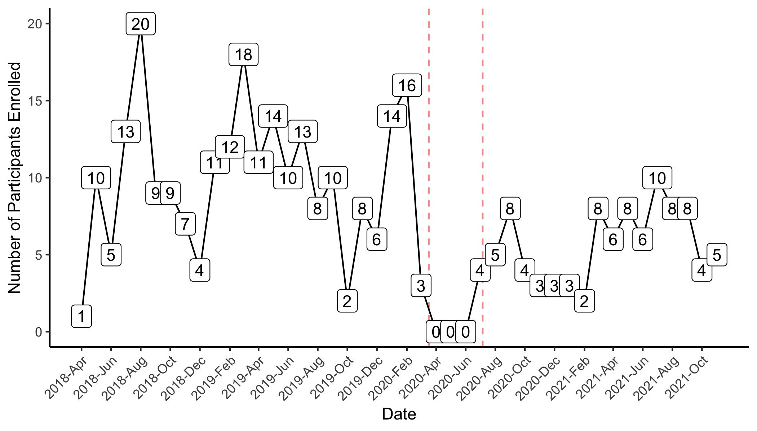

1. Recruitment began on April 17, 2018 and ended temporarily on March 17, 2020 due to COVID-19 and began again on July 6, 2020

2. Graph does not include participants that screened out during baseline assessment

Average recruitment (*2020-03-17 to 2020-07-05 not included in the denominator*):

* Overall = 8.0 per month
* Pre-COVID = 9.8 per month
* Post-COVID = 5.6 per month

**Figure 3.** Monthly recruitment stratified by year.

